 | 12.1.16 Editors - Geometry Nodes Editor - Header - Add Menu - Vector
Table of content
Detailed table of content 1
Add menu - Vector 2
Combine XYZ 2
Separate XYZ 2
Vector Math 2
Vector Rotate 3

Detailed table of content
Detailed table of content
Detailed table of content 1
Add menu - Vector 2
Combine XYZ 2
Input 2
X Y and Z 2
Output 2
Color 2
Separate XYZ 2
Input 2
Vector 2
Output 2
X, Y and Z 2
Vector Math 2
Inputs 3
Vector 3
Vector 3
Scale 3
Properties 3
Operation 3
Outputs 3
Vector 3
Value 3
Vector Rotate 3
Inputs 3
Vector 4
Center 4
Axis 4
Angle 4
Properties 4
Type 4
Outputs 4
Vector 4

Add menu - Vector
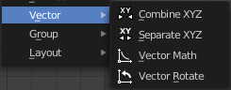
Vector nodes are for calculating vector operations.

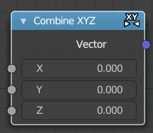
Combine XYZ
The Combine XYZ Node combines a vector from its individual components.

Input

X Y and Z
X, Y and Z values.

Output

Color
Color output.

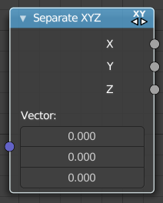
Separate XYZ
The Separate XYZ Node splits a vector into its individual components.

Input

Vector
The Input vector.

Output

X, Y and Z
The output vectors for X, Y and Z.

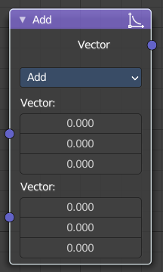
Vector Math
The Vector Math node performs the selected math operation on the input vectors.

Inputs
The inputs of the node are dynamic. Some inputs are only available in certain operations. For instance, the Scale input is only available in the Scale operator.

Vector
Input vector A.

Vector
Input vector B.

Scale
Input Scale.

Properties


Operation
The vector math operator to be applied on the input vectors.

Outputs
The output of the node is dynamic. It is either a vector or a scalar depending on the operator. For instance, the Length operator have a scalar output while the Add operator have a vector output.

Vector
Output vector.

Value
Output value.

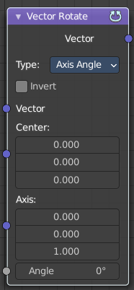
Vector Rotate
The Vector Rotate node allows rotations by a vector.

Inputs
The inputs of the node are dynamic. Some inputs are only available in certain operations. For instance, the Angle input is just available with the Axis Angle type.

Vector
Input vector.

Center
Input Center

Axis
Input Axis.

Angle
Input Angle

Properties

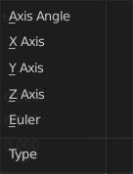
Type
The rotation type.

Outputs

Vector
The Output vector.

